

**CSE423: Computer Graphics**

**Summer 2021**

**Lab** **Assignment 1**

**Important Instructions for the Assignment:**

* For this assignment, you can choose either **Java** or **Python** environments.
* Before starting this assignment, please make sure you have installed the mentioned **OpenGL libraries** in your Java or Python System.
* The skeleton code will be provided. You can use that for completing the tasks or design your own.
* The submission link is given below. Please follow the submission instructions carefully. Failure to follow, will be subject to 20% to 50% marks penalty.
* The deadline for submission is to be strictly maintained. Late submission will be subject to marks deduction.
* Any form of plagiarism will automatically cancel your assignment. Please refrain from such activities.

**Assignment Submission Link:** [**https://forms.gle/BpxfHoetuknsmhYj9**](https://forms.gle/BpxfHoetuknsmhYj9)

**Assignment Deadline:**

**Task 1: Drawing Pixels**

You are supposed to draw **50 pixels** (coordinate points). For this you need to generate **100 random** values (50 x - coordinates and 50 y - coordinates). You do not need to join any pixels for this task.

**Task 2: House Building**

You are to draw a **House** using the base primitives: points, lines, or triangles. You can use ***GL_POINTS***, ***GL_LINES*** or ***GL_TRIANGLES*** for designing this house. A diagram has been provided as an example. You can modify the house design to your liking.

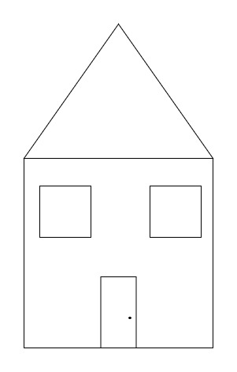

**Task 3: Coin Toss using Digital Differential Analyzer (DDA) Line Drawing Algorithm**

We are to demonstrate a coin toss with two sides: Heads or Tails. Depending on the **last digit of Brac University Student Id**, the output of the coin toss will be determined. If the last digit is an **odd number**, then the output of the coin will be **H** (head), or else **T** (tail) for an even **number**. You can consider 0 as an even number.

**Special Instructions:**

* You are to have **at least one dashed line** while designing the desired output. The other lines can be straight lines. An example has been attached for your better understanding.
* For designing the dashed line, you can give some pixel gaps.
* You cannot use ***GL_POINTS***, ***GL_LINES*** or ***GL_TRIANGLES.***

**Sample Example 1:**

**Student Id: 20311212**

**Output:**

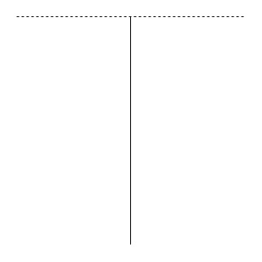

The last digit of 20311212 is **2**, which is an **even** number and thus your output will be **Tails**. Notice the upper line is dashed. You can have either one of the lines as dashed or both.

**Sample Example 2:**

**Student Id: 15101111**

**Output:**

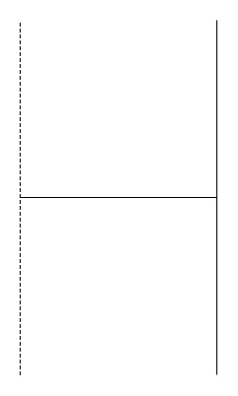

As the last digit of 15101111 is **odd**, so it will generate **Heads**. Again you can have any amount of dashed lines, but a minimum of one is mandatory.